To,
The Case Officer,
UKVI
Home Office

27th February 2026

Application: 1212-0001-5934-1594/00, and 01

Re: Skilled worker and dependant visa applications – Mrs Gugulethu Ndhlovu and Mr. Gaylode Chinzvende.

Dear Sir/Madam,

We are writing as immigration advisors on behalf of Mrs Gugulethu Ndhlovu, her husband Mr. Gaylode Chinzvende, in relation to their skilled worker and dependant visas respectively.
The applicant is currently in the United Kingdom on a skilled worker visa and her husband as dependant and had recently received a Certificate of Sponsorship for extension from his sponsoring employer. The applicants now wishes to apply to extend their permission.
We respectfully request that the application be granted, allowing the applicants to remain in the United Kingdom and continue progressing in their respective careers.
We trust that the documents provided are sufficient, however, please do not hesitate to contact us should you require any further information or documents in support of this application. Thank you for your time and understanding.

Sincerely,
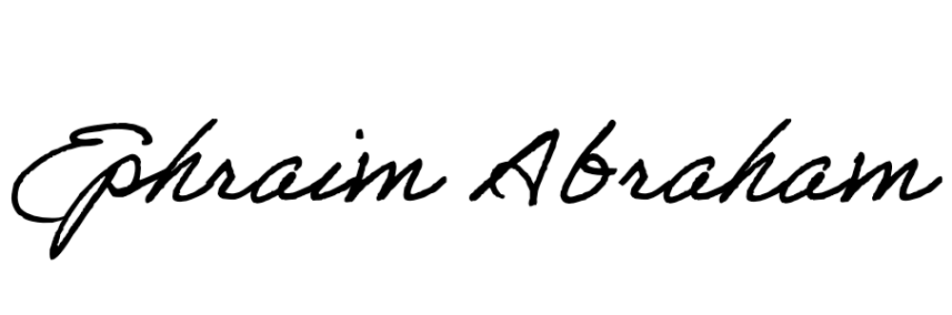
Ephraim Abraham
Immigration Advisor
ephraim@l-cedar.com

